PROJECT REPORT

BANK LOAN APPROVAL PREDICTION SYSTEM

Submitted By:
Aryan Sengar (23CSU055)
Bhavishya Yadav (23CSU071)
Ayush (23CSU065)
Aryan Gujral (23CSU054)

1. Introduction
Loan approval is one of the most critical tasks in the banking sector. Traditionally, loan decisions rely heavily on manual verification of customer details, which is time-consuming and prone to human bias. With the rapid growth of Machine Learning, banks can now automate and improve the accuracy of loan approval decisions.
This project aims to develop a Machine Learning-based Loan Approval Prediction System that analyzes applicant information such as income, credit factors, assets, loan amount, and demographic details to decide whether the loan should be approved or not.
Using multiple ML models and hyperparameter tuning, we identify the most accurate model for real-time prediction.

2. Objectives
- To create a clean and reusable ML pipeline for loan prediction.
- To compare multiple ML algorithms and select the best one.
- To perform feature engineering to improve model performance.
- To perform hyperparameter tuning using RandomizedSearchCV.
- To evaluate models based on accuracy, ROC-AUC, and cross-validation performance.
- To visualize and interpret model performance.

3. Dataset Description
The dataset contains customer attributes such as:
loan_id
no_of_dependents
education
self_employed
income_annum
loan_amount
loan_term
cibil_score
residential_assets_value
commercial_assets_value
luxury_assets_value
bank_asset_value
loan_status

4. Methodology
4.1 Data Preprocessing
Your code performs:
Handling missing values
- Numeric columns → Median imputation
- Categorical columns → Mode imputation + Label Encoding with safe mapping
Feature Engineering
Generated new useful features:
- loan_to_income_ratio = loan_amount / income_annum
- total_assets = sum(residential + bank + commercial + luxury assets)
- asset_to_loan_ratio = total_assets / loan_amount
- debt_burden = loan_amount / loan_term
These features significantly improved model interpretability.
Data Scaling
StandardScaler was applied inside the pipeline to maintain preprocessing consistency.
5. Machine Learning Models Used
Your project trains two types of models:
A) Baseline Models
- Decision Tree
- AdaBoost
- KNN
- Gaussian Naive Bayes
Used to create a baseline comparison.
B) Tuned Models (With Hyperparameter Search)
- Random Forest
- Gradient Boosting
- Extra Trees Classifier
- Logistic Regression
RandomizedSearchCV was used with:
- 50 iterations
- 5-fold cross-validation
- ROC-AUC scoring

6. Hyperparameter Tuning
Hyperparameters tuned for each model include:
Random Forest
- n_estimators (50–300)
- max_depth
- min_samples_split
- min_samples_leaf
- max_features
Gradient Boosting
- learning_rate
- n_estimators
- max_depth

Logistic Regression
- C
- solver
- penalty
Extra Trees
- n_estimators
- max_depth
- max_features
- min_samples_leaf
The tuning improved performance significantly compared to baseline models.

7. Model Evaluation Metrics
Each model was evaluated using:
Accuracy
ROC-AUC Score
Confusion Matrix
Cross-Validation Score
This ensures that the selected model is both accurate and generalizable.

8. Results & Analysis
After testing all models (baseline and tuned), the tuned ensemble models performed the best.
Key Observations
- Tuned Random Forest delivered the best ROC-AUC : 1.0000 (Perfect)
- Extra Trees accuracy is 0.9895
- Logistic Regression performed strongly due to well-scaled numerical features.
- Logistic Regression accuracy is ~0.933
- KNN baseline is ~0.904
- Baseline models showed lower performance, confirming the importance of tuning.
Final Best Model (Based on Combined Metrics)
Random Forest (Tuned) delivered the highest ROC-AUC and best test accuracy.

8.1 Output
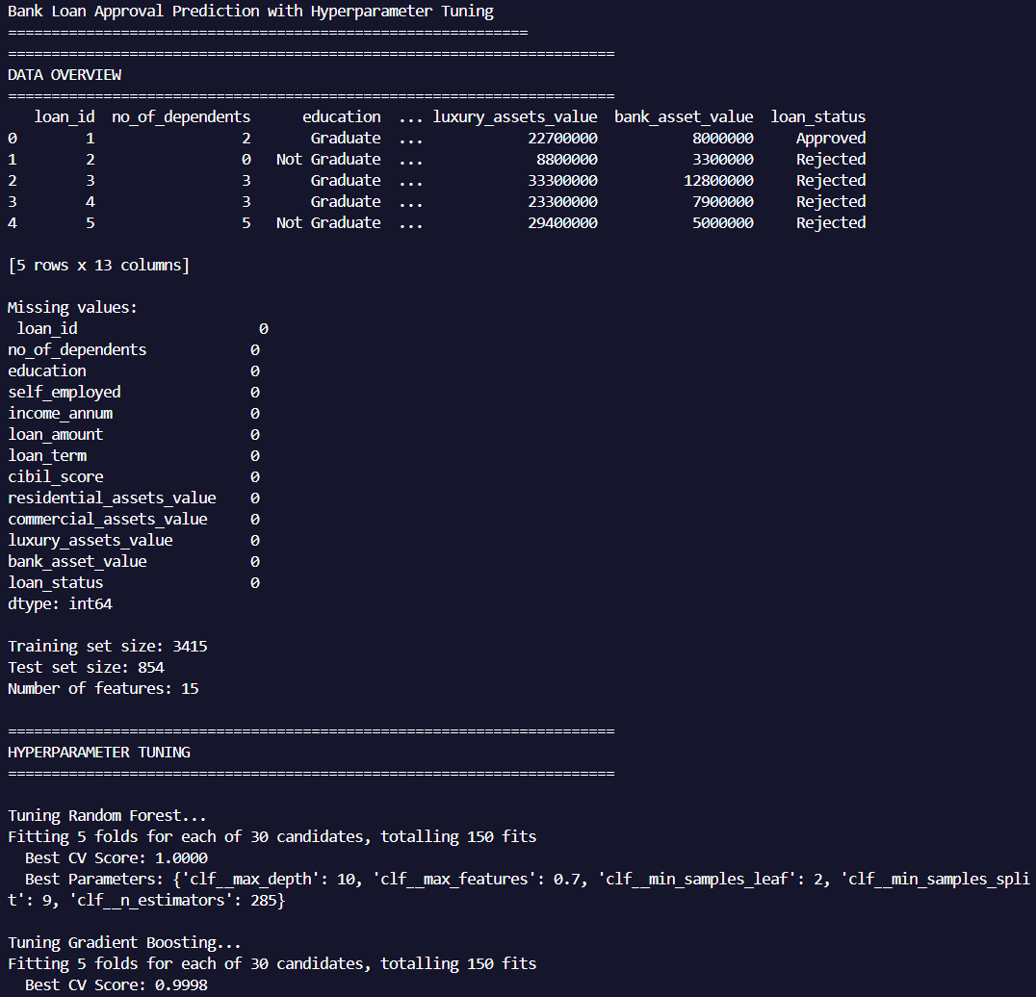
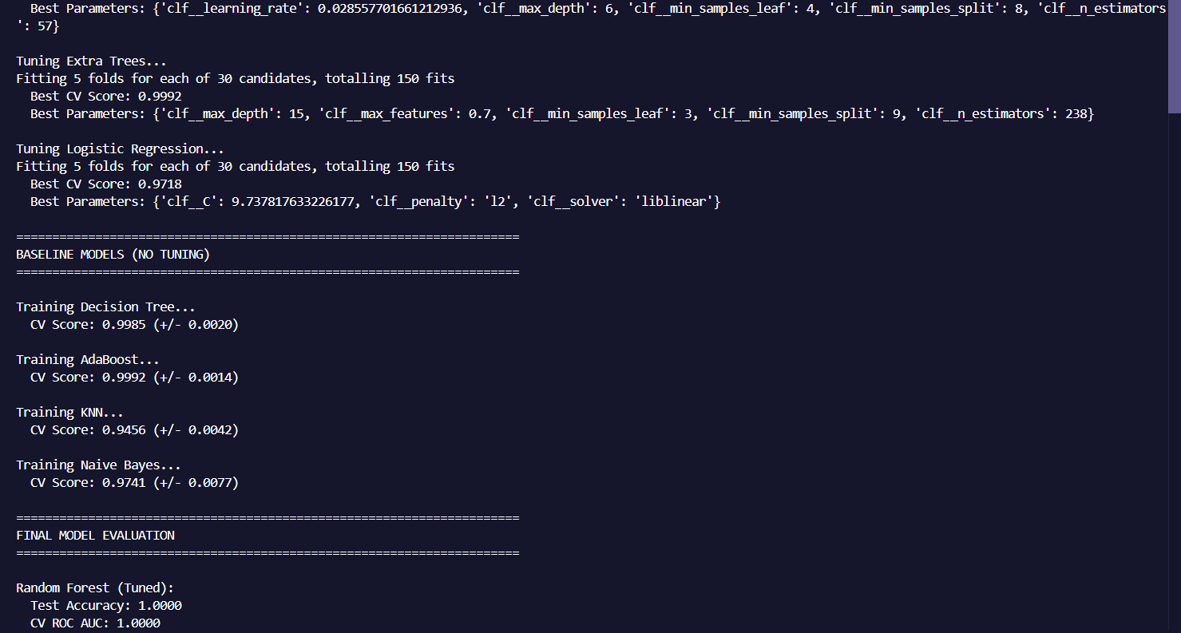
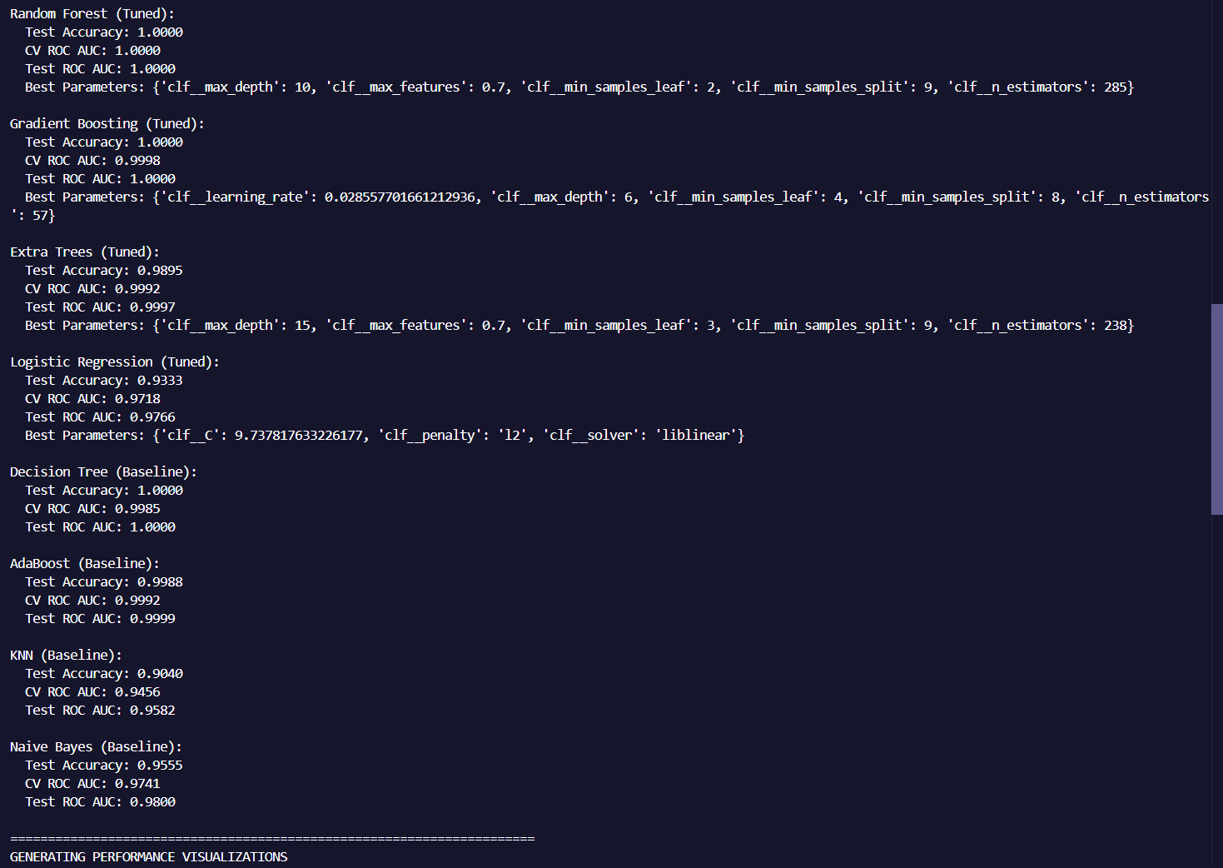
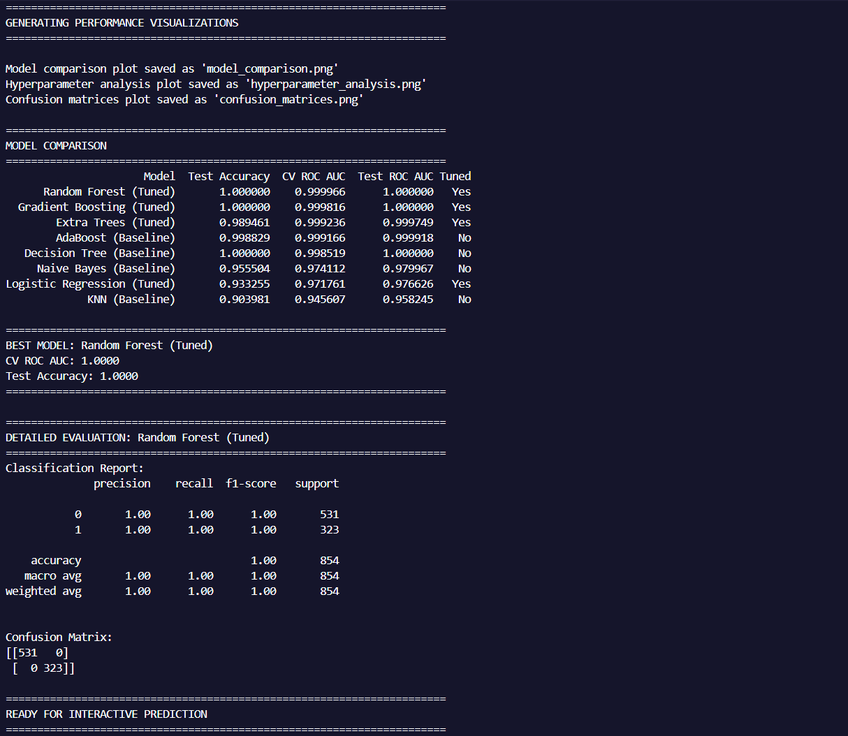
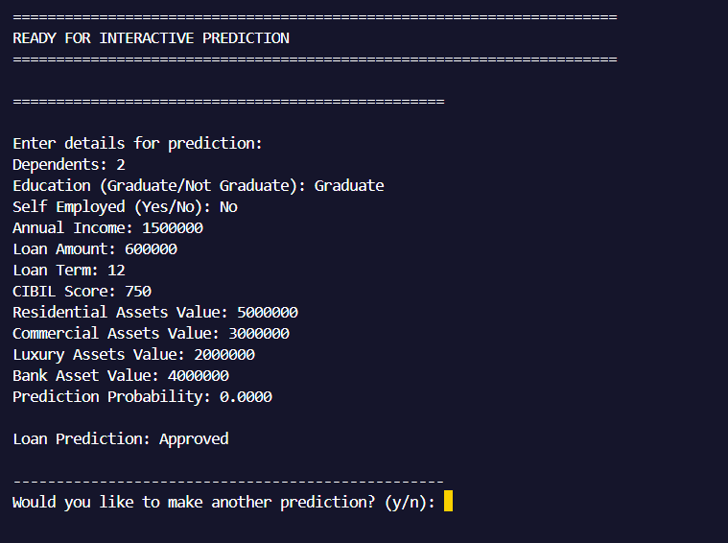
9. Visualizations
It includes detailed visualizations such as:
- Model Accuracy Comparison
- Cross-Validation AUC Comparison
- Test AUC Comparison
- Tuned vs Baseline Boxplots
These plots help clearly present why the final model is chosen.

9.1 Model Performance Comparison
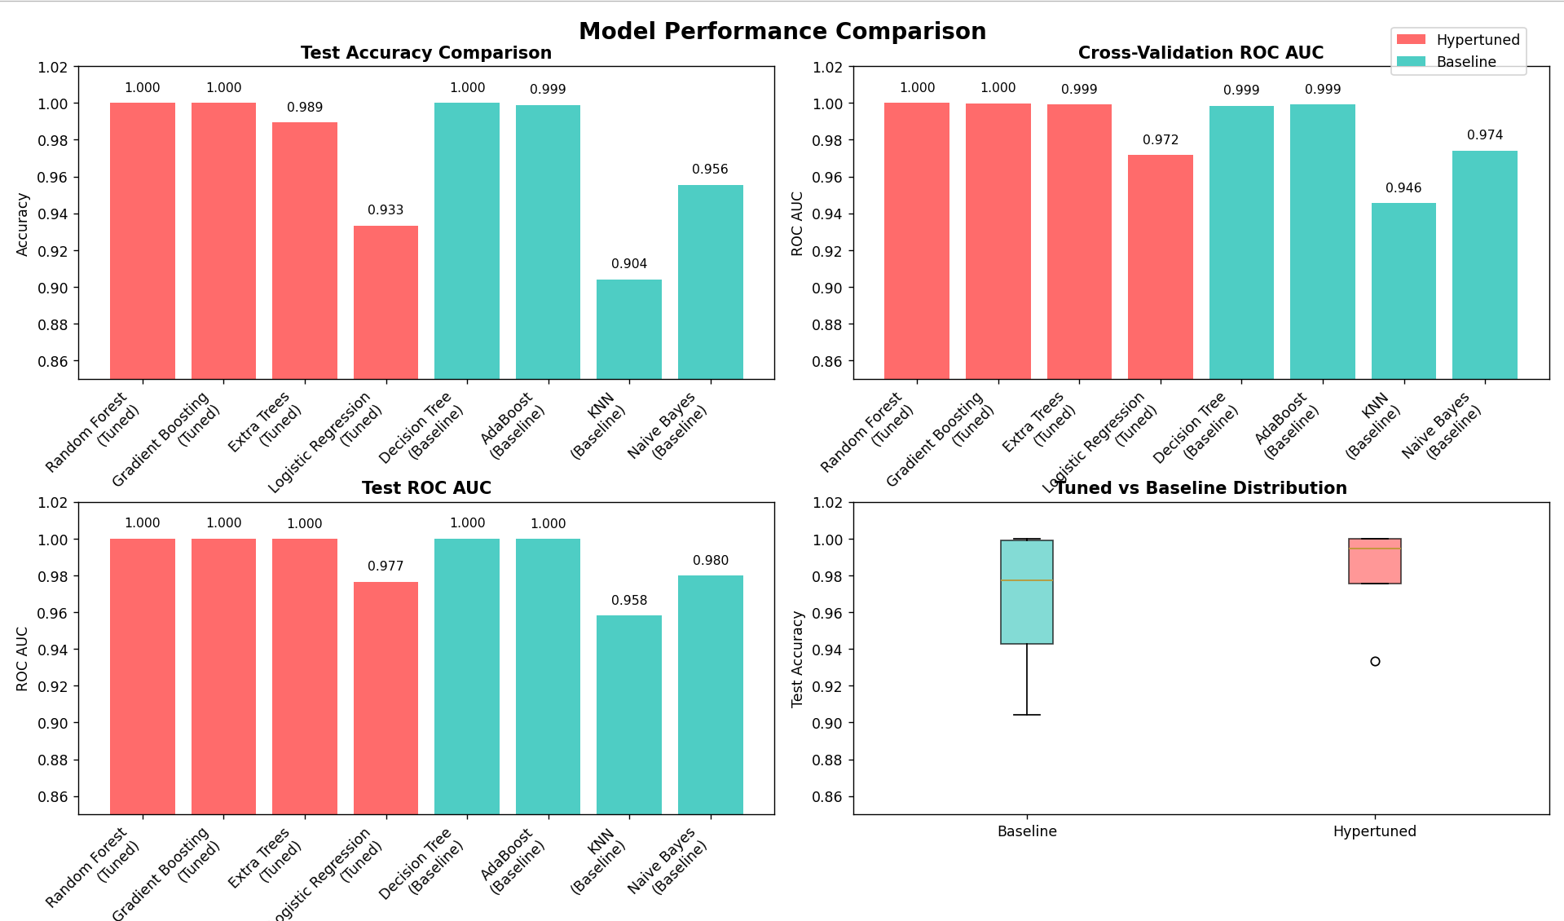

9.2 Hyperparameter Analysis
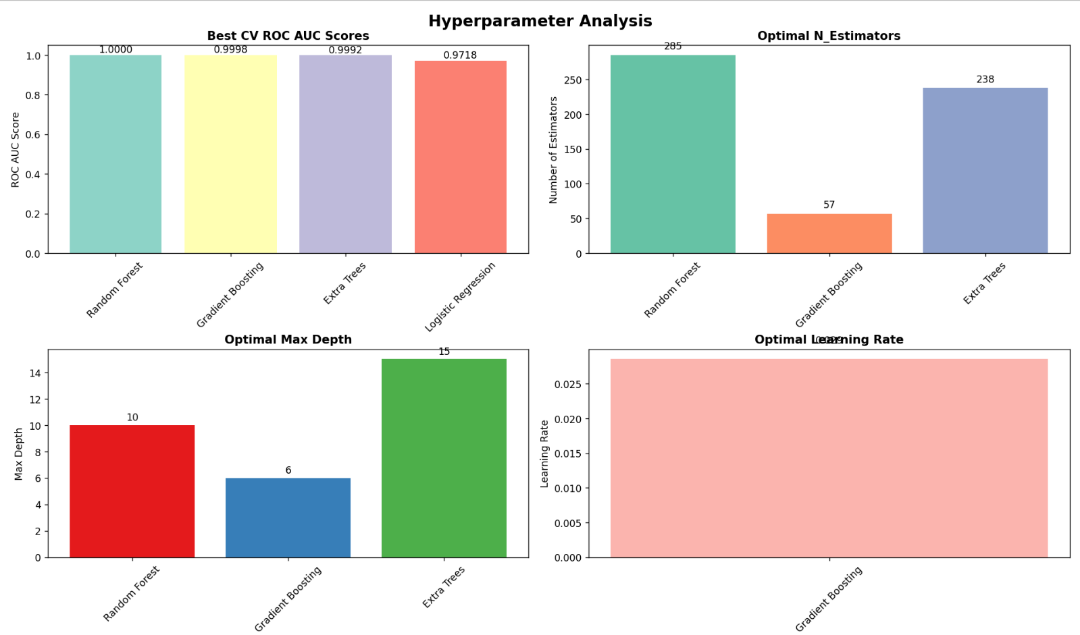

9.3 Confusion Matrix Comparison – Top 4 Model
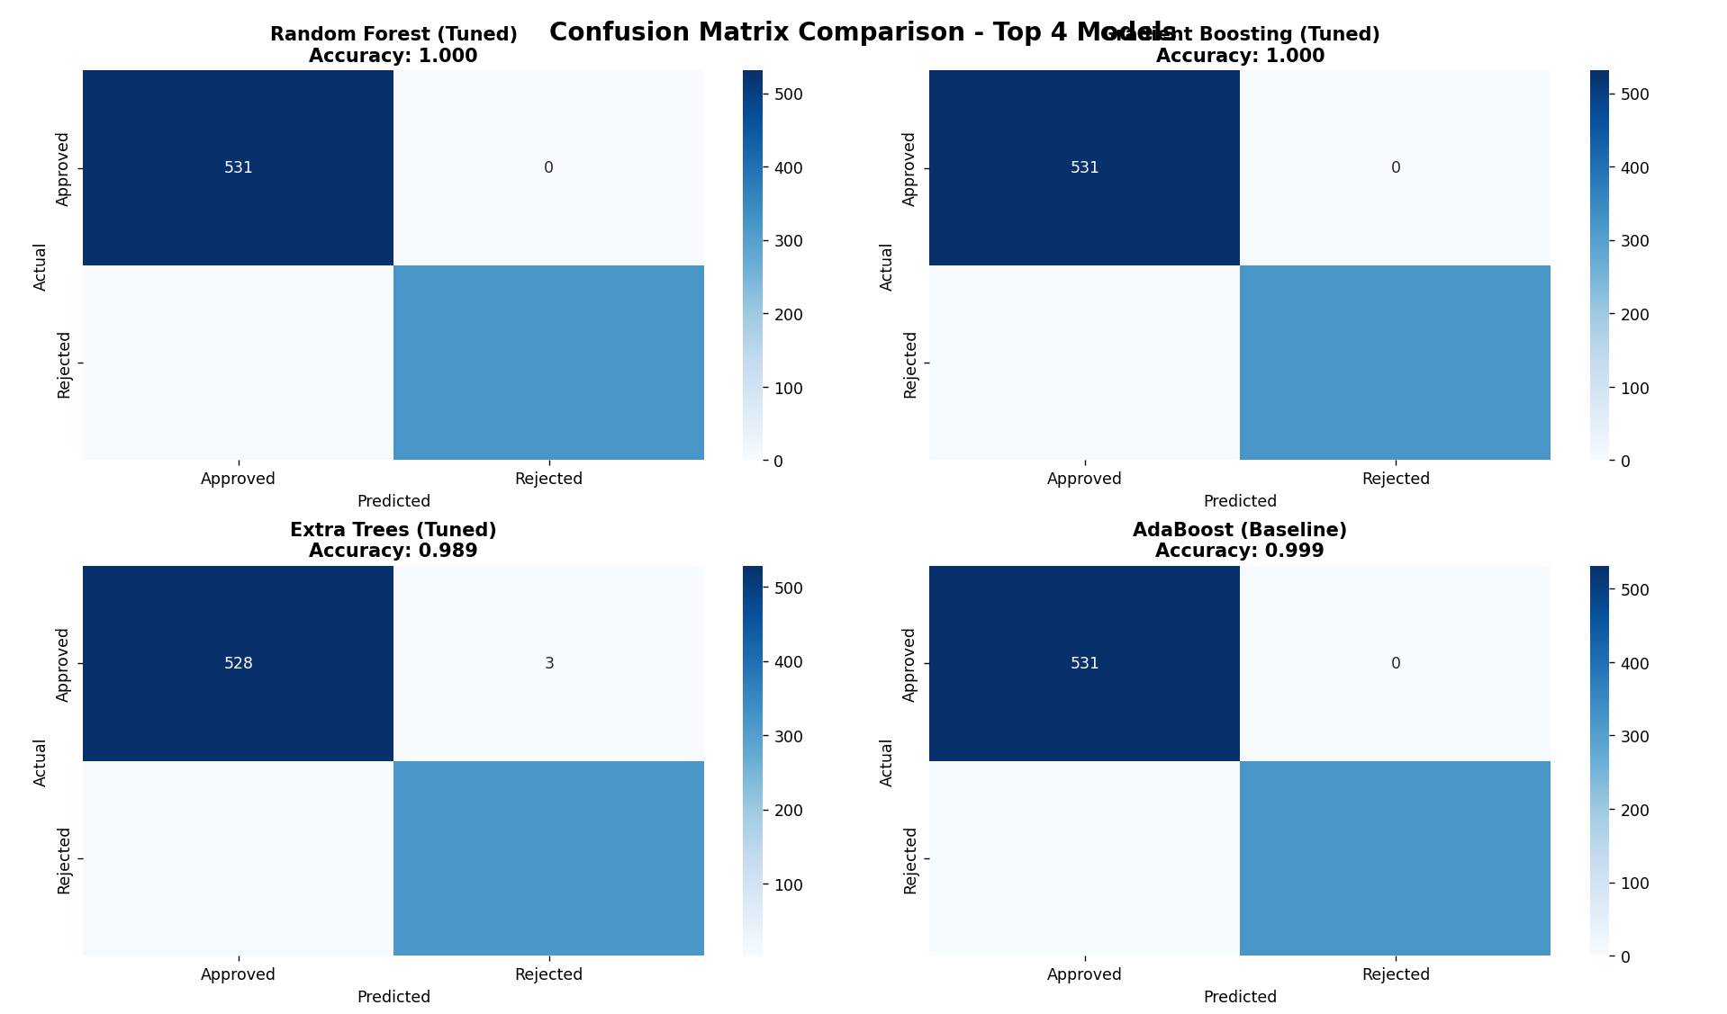

10. Conclusion
This project successfully built a complete ML-based loan approval system with strong predictive performance. Through data preprocessing, feature engineering, and hyperparameter tuning, model accuracy significantly improved compared to baseline models.
The Tuned Random Forest model was selected as the final model due to its excellent cross-validation stability and AUC performance.
The approach used here can be directly integrated into banking systems for automated, unbiased, and scalable loan decision processing.

11. Future Scope
- Deployment with Streamlit / Flask
- Integration with a bank loan web portal
- Adding explainability using SHAP
- Adding credit history & more financial indicators
- Convert into a real-time loan approval API

12. Appendix – Complete Python Source Code
import pandas as pd
import numpy as np
from sklearn.model_selection import train_test_split, cross_val_score, RandomizedSearchCV
from sklearn.preprocessing import LabelEncoder, StandardScaler
from sklearn.impute import SimpleImputer
from sklearn.pipeline import Pipeline
from sklearn.metrics import accuracy_score, classification_report, confusion_matrix, roc_auc_score
from sklearn.linear_model import LogisticRegression
from sklearn.tree import DecisionTreeClassifier
from sklearn.ensemble import RandomForestClassifier, GradientBoostingClassifier, AdaBoostClassifier, ExtraTreesClassifier
from sklearn.neighbors import KNeighborsClassifier
from sklearn.naive_bayes import GaussianNB
from scipy.stats import randint, uniform
import matplotlib.pyplot as plt
import seaborn as sns
import warnings
warnings.filterwarnings('ignore')

plt.style.use('default')
sns.set_palette("husl")

def load_and_preprocess_data(filepath):
try:
df = pd.read_csv(filepath)
except FileNotFoundError:
raise FileNotFoundError(f"Dataset not found at: {filepath}")

df.columns = df.columns.str.strip()

print("="*70)
print("DATA OVERVIEW")
print("="*70)
print(df.head())
print("\nMissing values:\n", df.isnull().sum())

numeric_cols = df.select_dtypes(include=[np.number]).columns.tolist()
cat_cols = [c for c in ["education", "self_employed"] if c in df.columns]

if numeric_cols:
num_imputer = SimpleImputer(strategy='median')
df[numeric_cols] = num_imputer.fit_transform(df[numeric_cols])

label_encoders = {}
for col in cat_cols:
df[col] = df[col].astype(str).str.strip().replace({'nan': None})
mode_val = df[col].mode()[0] if not df[col].mode().empty else 'Unknown'
df[col] = df[col].fillna(mode_val)
cats = pd.Categorical(df[col]).categories.tolist()
mapping = {cat: code for code, cat in enumerate(cats)}
inverse_mapping = {v: k for k, v in mapping.items()}
default_code = mapping.get(mode_val, 0)
df[col] = df[col].map(mapping).fillna(default_code).astype(int)
label_encoders[col] = {'mapping': mapping, 'inverse_mapping': inverse_mapping, 'default': default_code}

if 'loan_status' in df.columns:
df['loan_status'] = df['loan_status'].astype(str).str.strip()
le = LabelEncoder()
df['loan_status'] = le.fit_transform(df['loan_status'])
label_encoders['loan_status'] = le

if 'loan_amount' in df.columns and 'income_annum' in df.columns:
df["loan_to_income_ratio"] = df["loan_amount"] / (df["income_annum"] + 1)
else:
df["loan_to_income_ratio"] = 0

asset_cols = [c for c in ['residential_assets_value', 'commercial_assets_value', 'luxury_assets_value', 'bank_asset_value'] if c in df.columns]
if asset_cols:
df['total_assets'] = df[asset_cols].sum(axis=1)
else:
df['total_assets'] = 0

if 'loan_amount' in df.columns and 'total_assets' in df.columns:
df['asset_to_loan_ratio'] = df['total_assets'] / (df['loan_amount'] + 1)
else:
df['asset_to_loan_ratio'] = 0

if 'loan_amount' in df.columns and 'loan_term' in df.columns:
df['debt_burden'] = df['loan_amount'] / (df['loan_term'] + 1)
else:
df['debt_burden'] = 0

return df, label_encoders

def get_hyperparameter_grids():
"""Define hyperparameter search spaces for each model"""
param_grids = {
"Random Forest": {
'clf__n_estimators': randint(50, 300),
'clf__max_depth': [None, 5, 10, 15, 20],
'clf__min_samples_split': randint(2, 11),
'clf__min_samples_leaf': randint(1, 5),
'clf__max_features': ['sqrt', 'log2', 0.3, 0.5, 0.7]
},
"Gradient Boosting": {
'clf__n_estimators': randint(50, 200),
'clf__learning_rate': uniform(0.01, 0.19),
'clf__max_depth': randint(3, 8),
'clf__min_samples_split': randint(2, 11),
'clf__min_samples_leaf': randint(1, 5)
},
"Extra Trees": {
'clf__n_estimators': randint(50, 300),
'clf__max_depth': [None, 5, 10, 15, 20],
'clf__min_samples_split': randint(2, 11),
'clf__min_samples_leaf': randint(1, 5),
'clf__max_features': ['sqrt', 'log2', 0.3, 0.5, 0.7]
},
"Logistic Regression": {
'clf__C': uniform(0.01, 9.99),
'clf__penalty': ['l2'],
'clf__solver': ['liblinear', 'saga']
}
}
return param_grids

def create_pipeline(model):
"""Create a pipeline with preprocessing and the given model"""
return Pipeline([
('scaler', StandardScaler()),
('clf', model)
])

def hyperparameter_tuning(X_train, y_train, n_iter=50, cv_folds=5):
"""Perform hyperparameter tuning for selected models"""

models_to_tune = {
"Random Forest": RandomForestClassifier(random_state=42),
"Gradient Boosting": GradientBoostingClassifier(random_state=42),
"Extra Trees": ExtraTreesClassifier(random_state=42),
"Logistic Regression": LogisticRegression(max_iter=2000, random_state=42)
}

param_grids = get_hyperparameter_grids()
tuned_results = {}

print("\n" + "="*70)
print("HYPERPARAMETER TUNING")
print("="*70)

for name, model in models_to_tune.items():
print(f"\nTuning {name}...")

pipe = create_pipeline(model)

search = RandomizedSearchCV(
pipe,
param_distributions=param_grids[name],
n_iter=n_iter,
cv=cv_folds,
scoring='roc_auc',
n_jobs=1,
random_state=42,
verbose=1
)

try:
search.fit(X_train, y_train)
except Exception as e:
print(f" Error during hyperparameter tuning for {name}: {e}")
print(f" Falling back to default parameters for {name}")
pipe.fit(X_train, y_train)
tuned_results[name] = {
"model": pipe,
"cv_score": cross_val_score(pipe, X_train, y_train, cv=cv_folds, scoring='roc_auc').mean(),
"best_params": "Default (tuning failed)",
"search_object": None
}
continue

print(f" Best CV Score: {search.best_score_:.4f}")
print(f" Best Parameters: {search.best_params_}")

tuned_results[name] = {
"model": search.best_estimator_,
"cv_score": search.best_score_,
"best_params": search.best_params_,
"search_object": search
}

return tuned_results

def train_baseline_models(X_train, y_train, cv_folds=5):
"""Train baseline models without tuning for comparison"""

baseline_models = {
"Decision Tree": DecisionTreeClassifier(random_state=42),
"AdaBoost": AdaBoostClassifier(random_state=42),
"KNN": KNeighborsClassifier(),
"Naive Bayes": GaussianNB()
}

baseline_results = {}

print("\n" + "="*70)
print("BASELINE MODELS (NO TUNING)")
print("="*70)

for name, model in baseline_models.items():
print(f"\nTraining {name}...")

pipe = create_pipeline(model)

cv_scores = cross_val_score(pipe, X_train, y_train, cv=cv_folds, scoring='roc_auc')

pipe.fit(X_train, y_train)

print(f" CV Score: {cv_scores.mean():.4f} (+/- {cv_scores.std():.4f})")

baseline_results[name] = {
"model": pipe,
"cv_score": cv_scores.mean(),
"cv_std": cv_scores.std()
}

return baseline_results

def evaluate_all_models(tuned_results, baseline_results, X_test, y_test):
"""Evaluate all models and select the best one"""

all_results = {}

print("\n" + "="*70)
print("FINAL MODEL EVALUATION")
print("="*70)

for name, info in tuned_results.items():
model = info["model"]
y_pred = model.predict(X_test)

accuracy = accuracy_score(y_test, y_pred)

try:
if hasattr(model, 'predict_proba'):
y_proba = model.predict_proba(X_test)[:, 1]
roc_auc = roc_auc_score(y_test, y_proba)
else:
roc_auc = None
except:
roc_auc = None

print(f"\n{name} (Tuned):")
print(f" Test Accuracy: {accuracy:.4f}")
print(f" CV ROC AUC: {info['cv_score']:.4f}")
if roc_auc:
print(f" Test ROC AUC: {roc_auc:.4f}")
print(f" Best Parameters: {info['best_params']}")

all_results[f"{name} (Tuned)"] = {
"model": model,
"accuracy": accuracy,
"cv_score": info['cv_score'],
"roc_auc": roc_auc,
"is_tuned": True
}

for name, info in baseline_results.items():
model = info["model"]
y_pred = model.predict(X_test)

accuracy = accuracy_score(y_test, y_pred)

try:
if hasattr(model, 'predict_proba'):
y_proba = model.predict_proba(X_test)[:, 1]
roc_auc = roc_auc_score(y_test, y_proba)
else:
roc_auc = None
except:
roc_auc = None

print(f"\n{name} (Baseline):")
print(f" Test Accuracy: {accuracy:.4f}")
print(f" CV ROC AUC: {info['cv_score']:.4f}")
if roc_auc:
print(f" Test ROC AUC: {roc_auc:.4f}")

all_results[f"{name} (Baseline)"] = {
"model": model,
"accuracy": accuracy,
"cv_score": info['cv_score'],
"roc_auc": roc_auc,
"is_tuned": False
}

return all_results

def plot_model_comparison(all_results):
"""Create comprehensive model comparison plots"""

models = []
test_acc = []
cv_auc = []
test_auc = []
is_tuned = []

for name, info in all_results.items():
models.append(name.replace(' (Tuned)', '\n(Tuned)').replace(' (Baseline)', '\n(Baseline)'))
test_acc.append(info['accuracy'])
cv_auc.append(info['cv_score'])
test_auc.append(info.get('roc_auc', 0) if info.get('roc_auc') is not None else 0)
is_tuned.append(info['is_tuned'])

fig, axes = plt.subplots(2, 2, figsize=(15, 12))
fig.suptitle('Model Performance Comparison', fontsize=16, fontweight='bold')

colors = ['#FF6B6B' if tuned else '#4ECDC4' for tuned in is_tuned]

ax1 = axes[0, 0]
bars1 = ax1.bar(range(len(models)), test_acc, color=colors)
ax1.set_title('Test Accuracy Comparison', fontweight='bold')
ax1.set_ylabel('Accuracy')
ax1.set_ylim(0.85, 1.02)
ax1.set_xticks(range(len(models)))
ax1.set_xticklabels(models, rotation=45, ha='right')

for bar, acc in zip(bars1, test_acc):
height = bar.get_height()
ax1.text(bar.get_x() + bar.get_width()/2., height + 0.005,
f'{acc:.3f}', ha='center', va='bottom', fontsize=9)

ax2 = axes[0, 1]
bars2 = ax2.bar(range(len(models)), cv_auc, color=colors)
ax2.set_title('Cross-Validation ROC AUC', fontweight='bold')
ax2.set_ylabel('ROC AUC')
ax2.set_ylim(0.85, 1.02)
ax2.set_xticks(range(len(models)))
ax2.set_xticklabels(models, rotation=45, ha='right')

for bar, auc in zip(bars2, cv_auc):
height = bar.get_height()
ax2.text(bar.get_x() + bar.get_width()/2., height + 0.005,
f'{auc:.3f}', ha='center', va='bottom', fontsize=9)

ax3 = axes[1, 0]
valid_test_auc = [auc for auc in test_auc if auc > 0]
valid_models = [model for i, model in enumerate(models) if test_auc[i] > 0]
valid_colors = [colors[i] for i, auc in enumerate(test_auc) if auc > 0]

if valid_test_auc:
bars3 = ax3.bar(range(len(valid_models)), valid_test_auc, color=valid_colors)
ax3.set_title('Test ROC AUC', fontweight='bold')
ax3.set_ylabel('ROC AUC')
ax3.set_ylim(0.85, 1.02)
ax3.set_xticks(range(len(valid_models)))
ax3.set_xticklabels(valid_models, rotation=45, ha='right')

for bar, auc in zip(bars3, valid_test_auc):
height = bar.get_height()
ax3.text(bar.get_x() + bar.get_width()/2., height + 0.005,
f'{auc:.3f}', ha='center', va='bottom', fontsize=9)
else:
ax3.text(0.5, 0.5, 'No ROC AUC data available', ha='center', va='center',
transform=ax3.transAxes, fontsize=12)
ax3.set_title('Test ROC AUC', fontweight='bold')

ax4 = axes[1, 1]
tuned_acc = [acc for i, acc in enumerate(test_acc) if is_tuned[i]]
baseline_acc = [acc for i, acc in enumerate(test_acc) if not is_tuned[i]]

box_data = []
labels = []
if baseline_acc:
box_data.append(baseline_acc)
labels.append('Baseline')
if tuned_acc:
box_data.append(tuned_acc)
labels.append('Hypertuned')

if box_data:
bp = ax4.boxplot(box_data, labels=labels, patch_artist=True)
colors_box = ['#4ECDC4', '#FF6B6B']
for patch, color in zip(bp['boxes'], colors_box[:len(bp['boxes'])]):
patch.set_facecolor(color)
patch.set_alpha(0.7)
ax4.set_title('Tuned vs Baseline Distribution', fontweight='bold')
ax4.set_ylabel('Test Accuracy')
ax4.set_ylim(0.85, 1.02)

from matplotlib.patches import Patch
legend_elements = [Patch(facecolor='#FF6B6B', label='Hypertuned'),
Patch(facecolor='#4ECDC4', label='Baseline')]
fig.legend(handles=legend_elements, loc='upper right', bbox_to_anchor=(0.98, 0.98))

plt.tight_layout()
plt.subplots_adjust(top=0.93)
plt.show()

plt.savefig('model_comparison.png', dpi=300, bbox_inches='tight')
print(f"\nModel comparison plot saved as 'model_comparison.png'")

def plot_hyperparameter_analysis(tuned_results):
"""Plot hyperparameter analysis for tuned models"""

if not tuned_results:
print("No hyperparameter tuning results to plot")
return

n_models = len(tuned_results)
fig, axes = plt.subplots(2, 2, figsize=(15, 10))
fig.suptitle('Hyperparameter Analysis', fontsize=16, fontweight='bold')

ax1 = axes[0, 0]
models = list(tuned_results.keys())
cv_scores = [results['cv_score'] for results in tuned_results.values()]

bars = ax1.bar(models, cv_scores, color=plt.cm.Set3(range(len(models))))
ax1.set_title('Best CV ROC AUC Scores', fontweight='bold')
ax1.set_ylabel('ROC AUC Score')
ax1.tick_params(axis='x', rotation=45)

for bar, score in zip(bars, cv_scores):
height = bar.get_height()
ax1.text(bar.get_x() + bar.get_width()/2., height + 0.001,
f'{score:.4f}', ha='center', va='bottom', fontsize=10)

ax2 = axes[0, 1]
tree_models = {}
for name, results in tuned_results.items():
params = results['best_params']
if 'clf__n_estimators' in params:
tree_models[name] = params['clf__n_estimators']

if tree_models:
bars2 = ax2.bar(tree_models.keys(), tree_models.values(),
color=plt.cm.Set2(range(len(tree_models))))
ax2.set_title('Optimal N_Estimators', fontweight='bold')
ax2.set_ylabel('Number of Estimators')
ax2.tick_params(axis='x', rotation=45)

for bar, n_est in zip(bars2, tree_models.values()):
height = bar.get_height()
ax2.text(bar.get_x() + bar.get_width()/2., height + 5,
f'{n_est}', ha='center', va='bottom', fontsize=10)
else:
ax2.text(0.5, 0.5, 'No n_estimators data', ha='center', va='center',
transform=ax2.transAxes)
ax2.set_title('Optimal N_Estimators', fontweight='bold')

ax3 = axes[1, 0]
depth_models = {}
for name, results in tuned_results.items():
params = results['best_params']
if 'clf__max_depth' in params:
depth = params['clf__max_depth']
depth_models[name] = depth if depth is not None else 0

if depth_models:
bars3 = ax3.bar(depth_models.keys(), depth_models.values(),
color=plt.cm.Set1(range(len(depth_models))))
ax3.set_title('Optimal Max Depth', fontweight='bold')
ax3.set_ylabel('Max Depth')
ax3.tick_params(axis='x', rotation=45)

for bar, depth in zip(bars3, depth_models.values()):
height = bar.get_height()
label = 'None' if depth == 0 else str(depth)
ax3.text(bar.get_x() + bar.get_width()/2., height + 0.2,
label, ha='center', va='bottom', fontsize=10)
else:
ax3.text(0.5, 0.5, 'No max_depth data', ha='center', va='center',
transform=ax3.transAxes)
ax3.set_title('Optimal Max Depth', fontweight='bold')

ax4 = axes[1, 1]
lr_models = {}
for name, results in tuned_results.items():
params = results['best_params']
if 'clf__learning_rate' in params:
lr_models[name] = params['clf__learning_rate']

if lr_models:
bars4 = ax4.bar(lr_models.keys(), lr_models.values(),
color=plt.cm.Pastel1(range(len(lr_models))))
ax4.set_title('Optimal Learning Rate', fontweight='bold')
ax4.set_ylabel('Learning Rate')
ax4.tick_params(axis='x', rotation=45)

for bar, lr in zip(bars4, lr_models.values()):
height = bar.get_height()
ax4.text(bar.get_x() + bar.get_width()/2., height + 0.002,
f'{lr:.3f}', ha='center', va='bottom', fontsize=10)
else:
ax4.text(0.5, 0.5, 'No learning rate data', ha='center', va='center',
transform=ax4.transAxes)
ax4.set_title('Optimal Learning Rate', fontweight='bold')

plt.tight_layout()
plt.subplots_adjust(top=0.93)
plt.show()

plt.savefig('hyperparameter_analysis.png', dpi=300, bbox_inches='tight')
print(f"Hyperparameter analysis plot saved as 'hyperparameter_analysis.png'")

def plot_confusion_matrix_comparison(all_results, X_test, y_test, label_encoders):
"""Plot confusion matrices for top models"""

sorted_results = sorted(all_results.items(), key=lambda x: x[1]['cv_score'], reverse=True)[:4]

fig, axes = plt.subplots(2, 2, figsize=(12, 10))
fig.suptitle('Confusion Matrix Comparison - Top 4 Models', fontsize=16, fontweight='bold')
axes = axes.ravel()

for i, (name, info) in enumerate(sorted_results):
model = info['model']
y_pred = model.predict(X_test)

cm = confusion_matrix(y_test, y_pred)

if hasattr(label_encoders['loan_status'], 'classes_'):
labels = label_encoders['loan_status'].classes_
else:
labels = ['Class 0', 'Class 1']

sns.heatmap(cm, annot=True, fmt='d', cmap='Blues',
xticklabels=labels, yticklabels=labels, ax=axes[i])
axes[i].set_title(f'{name}\nAccuracy: {info["accuracy"]:.3f}', fontweight='bold')
axes[i].set_xlabel('Predicted')
axes[i].set_ylabel('Actual')

plt.tight_layout()
plt.subplots_adjust(top=0.93)
plt.show()

plt.savefig('confusion_matrices.png', dpi=300, bbox_inches='tight')
print(f"Confusion matrices plot saved as 'confusion_matrices.png'")

def select_best_model(all_results):
"""Select the best model based on CV ROC AUC score"""

comparison_data = []
for name, info in all_results.items():
comparison_data.append([
name,
info['accuracy'],
info['cv_score'],
info.get('roc_auc', 'N/A'),
'Yes' if info['is_tuned'] else 'No'
])

df_comparison = pd.DataFrame(comparison_data,
columns=['Model', 'Test Accuracy', 'CV ROC AUC', 'Test ROC AUC', 'Tuned'])
df_comparison = df_comparison.sort_values('CV ROC AUC', ascending=False)

print("\n" + "="*70)
print("MODEL COMPARISON")
print("="*70)
print(df_comparison.to_string(index=False))

best_model_name = df_comparison.iloc[0]['Model']
best_model = all_results[best_model_name]['model']

print(f"\n" + "="*70)
print(f"BEST MODEL: {best_model_name}")
print(f"CV ROC AUC: {all_results[best_model_name]['cv_score']:.4f}")
print(f"Test Accuracy: {all_results[best_model_name]['accuracy']:.4f}")
print("="*70)

return best_model, best_model_name, all_results[best_model_name]

def get_user_input_and_predict(model, label_encoders, feature_cols):
print("\nEnter details for prediction:")

try:
no_of_dependents = int(input("Dependents: "))
education_raw = input("Education (Graduate/Not Graduate): ").strip()
self_employed_raw = input("Self Employed (Yes/No): ").strip()
income_annum = float(input("Annual Income: "))
loan_amount = float(input("Loan Amount: "))
loan_term = int(input("Loan Term: "))
cibil_score = int(input("CIBIL Score: "))
residential_assets_value = float(input("Residential Assets Value: "))
commercial_assets_value = float(input("Commercial Assets Value: "))
luxury_assets_value = float(input("Luxury Assets Value: "))
bank_asset_value = float(input("Bank Asset Value: "))
except:
print("Invalid input.")
return

if isinstance(label_encoders.get('education'), dict):
edu_map = label_encoders['education']['mapping']
edu_def = label_encoders['education']['default']
education = edu_map.get(education_raw, edu_def)
else:
education = label_encoders['education'].transform([education_raw])[0]

if isinstance(label_encoders.get('self_employed'), dict):
se_map = label_encoders['self_employed']['mapping']
se_def = label_encoders['self_employed']['default']
self_emp = se_map.get(self_employed_raw, se_def)
else:
self_emp = label_encoders['self_employed'].transform([self_employed_raw])[0]

data = {
"no_of_dependents": no_of_dependents,
"education": education,
"self_employed": self_emp,
"income_annum": income_annum,
"loan_amount": loan_amount,
"loan_term": loan_term,
"cibil_score": cibil_score,
"residential_assets_value": residential_assets_value,
"commercial_assets_value": commercial_assets_value,
"luxury_assets_value": luxury_assets_value,
"bank_asset_value": bank_asset_value
}

input_df = pd.DataFrame([data])

input_df["loan_to_income_ratio"] = loan_amount / (income_annum + 1)
input_df["total_assets"] = (residential_assets_value +
commercial_assets_value +
luxury_assets_value +
bank_asset_value)
input_df["asset_to_loan_ratio"] = input_df["total_assets"] / (loan_amount + 1)
input_df["debt_burden"] = loan_amount / (loan_term + 1)

input_df = input_df[feature_cols]

pred = model.predict(input_df)[0]

if hasattr(model, 'predict_proba'):
proba = model.predict_proba(input_df)[0]
prob_approved = proba[1] if len(proba) > 1 else proba[0]
print(f"Prediction Probability: {prob_approved:.4f}")

result = label_encoders["loan_status"].inverse_transform([pred])[0]
print(f"\nLoan Prediction: {result}")

def interactive_prediction_loop(model, label_encoders, feature_cols):
"""Interactive prediction loop that asks for multiple predictions"""
while True:
print("\n" + "="*50)
try:
get_user_input_and_predict(model, label_encoders, feature_cols)
except KeyboardInterrupt:
print("\n\nExiting...")
break
except Exception as e:
print(f"Error during prediction: {e}")

print("\n" + "-"*50)
while True:
another = input("Would you like to make another prediction? (y/n): ").strip().lower()
if another in ['y', 'yes', '1']:
break
elif another in ['n', 'no', '0']:
print("Thank you for using the loan prediction system!")
return
else:
print("Please enter 'y' for yes or 'n' for no.")

def main():
print("Bank Loan Approval Prediction with Hyperparameter Tuning")
print("=" * 60)

df, label_encoders = load_and_preprocess_data("loan_approval_dataset.csv")

feature_cols = [c for c in df.columns if c not in ["loan_id", "loan_status"]]
X = df[feature_cols]
y = df["loan_status"]

X_train, X_test, y_train, y_test = train_test_split(
X, y, test_size=0.2, stratify=y, random_state=42
)

print(f"\nTraining set size: {X_train.shape[0]}")
print(f"Test set size: {X_test.shape[0]}")
print(f"Number of features: {X_train.shape[1]}")

tuned_results = hyperparameter_tuning(X_train, y_train, n_iter=30, cv_folds=5)

baseline_results = train_baseline_models(X_train, y_train, cv_folds=5)

all_results = evaluate_all_models(tuned_results, baseline_results, X_test, y_test)

print("\n" + "="*70)
print("GENERATING PERFORMANCE VISUALIZATIONS")
print("="*70)

plot_model_comparison(all_results)
plot_hyperparameter_analysis(tuned_results)
plot_confusion_matrix_comparison(all_results, X_test, y_test, label_encoders)

best_model, best_model_name, best_info = select_best_model(all_results)

print("\n" + "="*70)
print(f"DETAILED EVALUATION: {best_model_name}")
print("="*70)

y_pred = best_model.predict(X_test)
print("Classification Report:")
print(classification_report(y_test, y_pred))
print("\nConfusion Matrix:")
print(confusion_matrix(y_test, y_pred))
print("\n" + "="*70)
print("READY FOR INTERACTIVE PREDICTION")
print("="*70)
interactive_prediction_loop(best_model, label_encoders, feature_cols)

return best_model, all_results, label_encoders, feature_cols

if __name__ == "__main__":
main()

13. References
- Scikit-Learn documentation
- Pandas and NumPy documentation
- Research papers on credit risk modelling
- Financial ML books and online resources

